|  |  |
| --- | --- |
| **Course Code: CSL601** | **Course Name: SE LAB** |
| **Class: TE-CO** | **Batch: 3** |
| **Roll no: 18CO63** | **Name: TAUSEEF MUSHTAQUE ALI SHAIKH** |

**Experiment: 10**

**Aim: Develop test cases for the project using white box testing.**

**Output:**

**Test case scenario 1: Testing the PopUp by the Extention.**

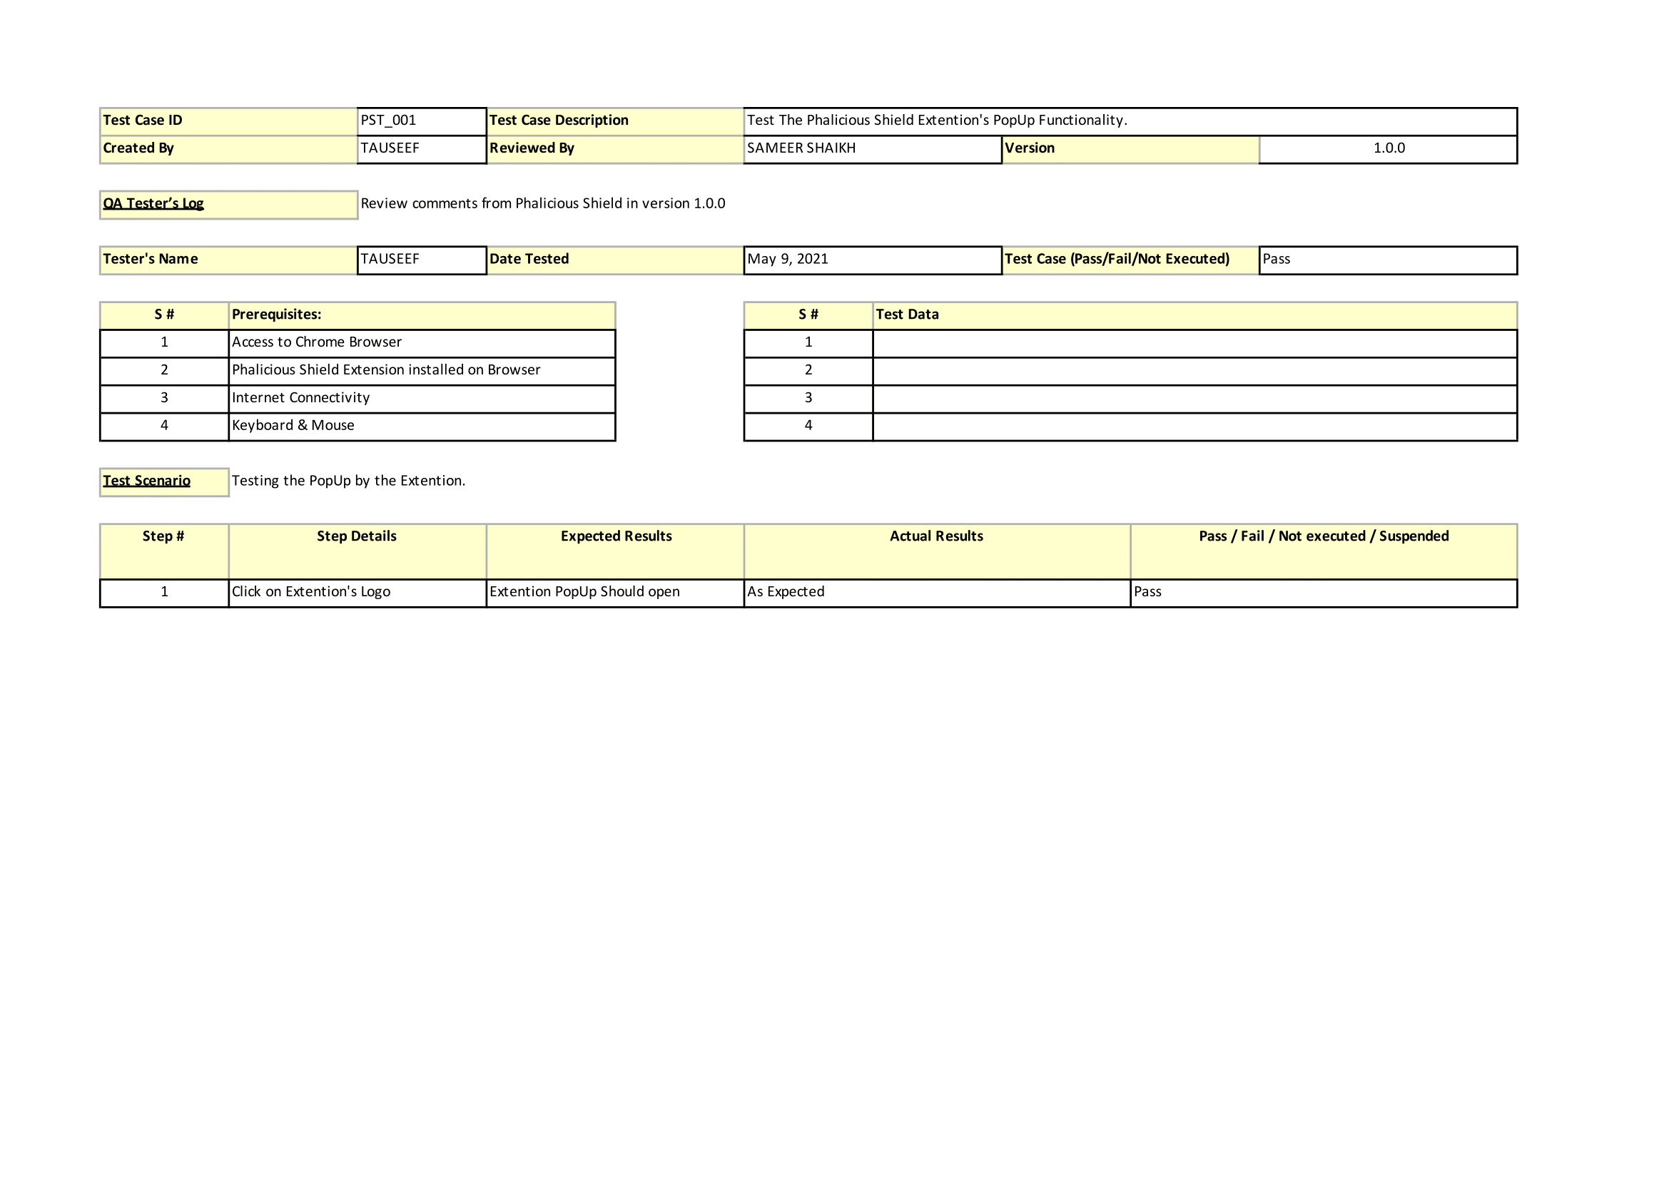

**Test case scenario 2: Testing the Buttons on the Extention PopUp.**

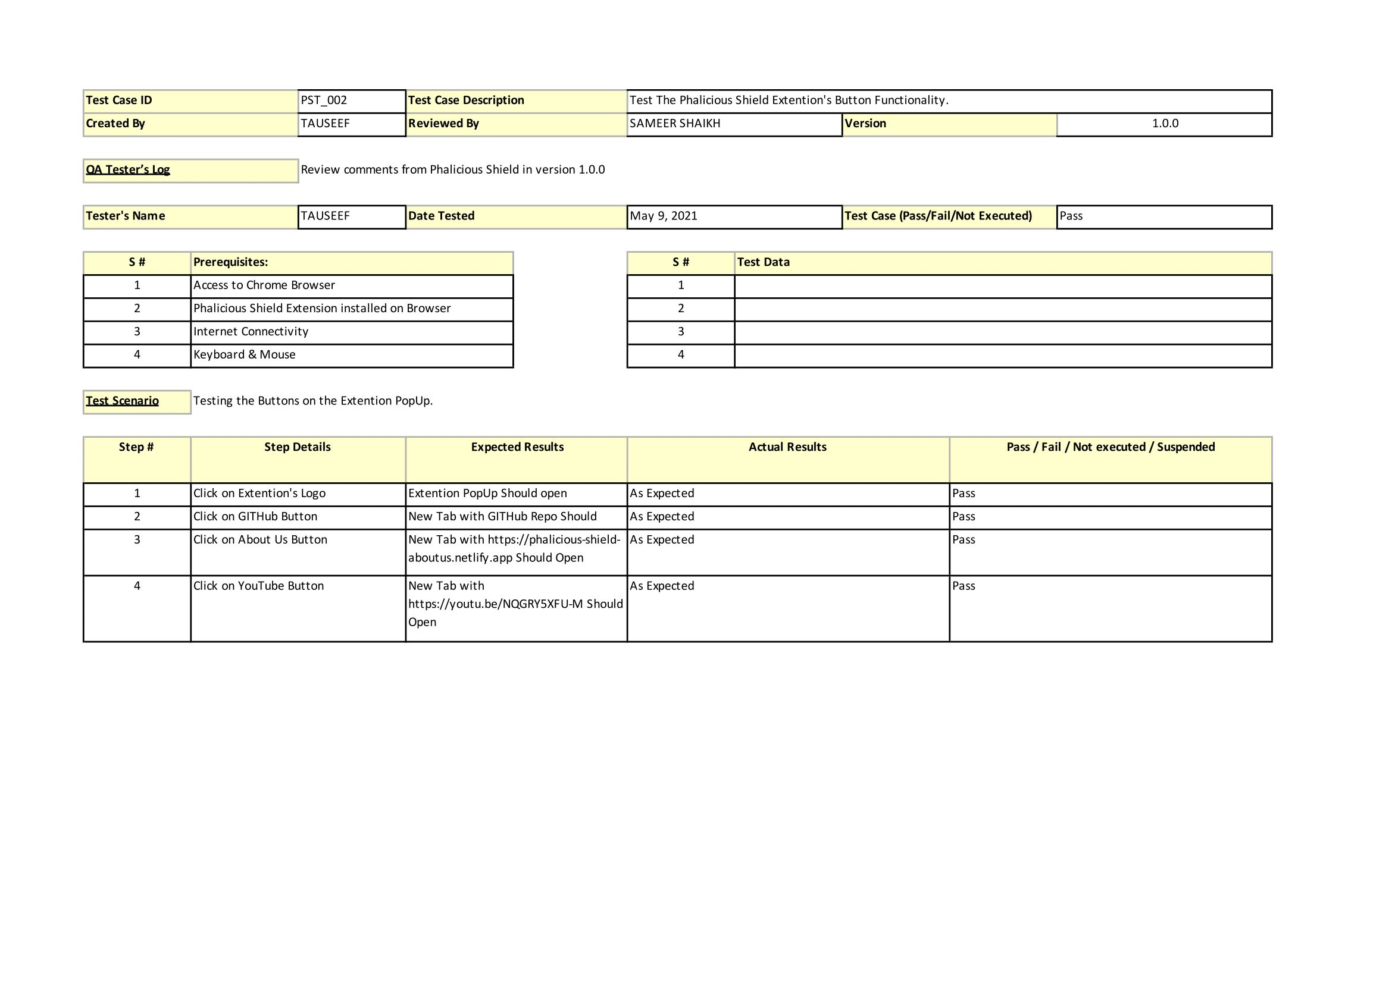

**Test case scenario 3: Testing the Alert by the Extention.**

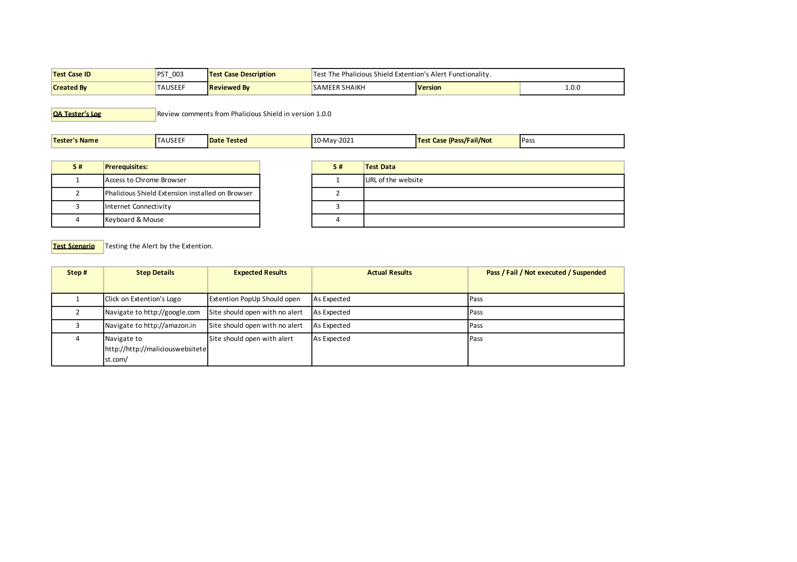

**Test case scenario 4: Testing the Empty URL & New Tab non-Alert Function by the Extention.**

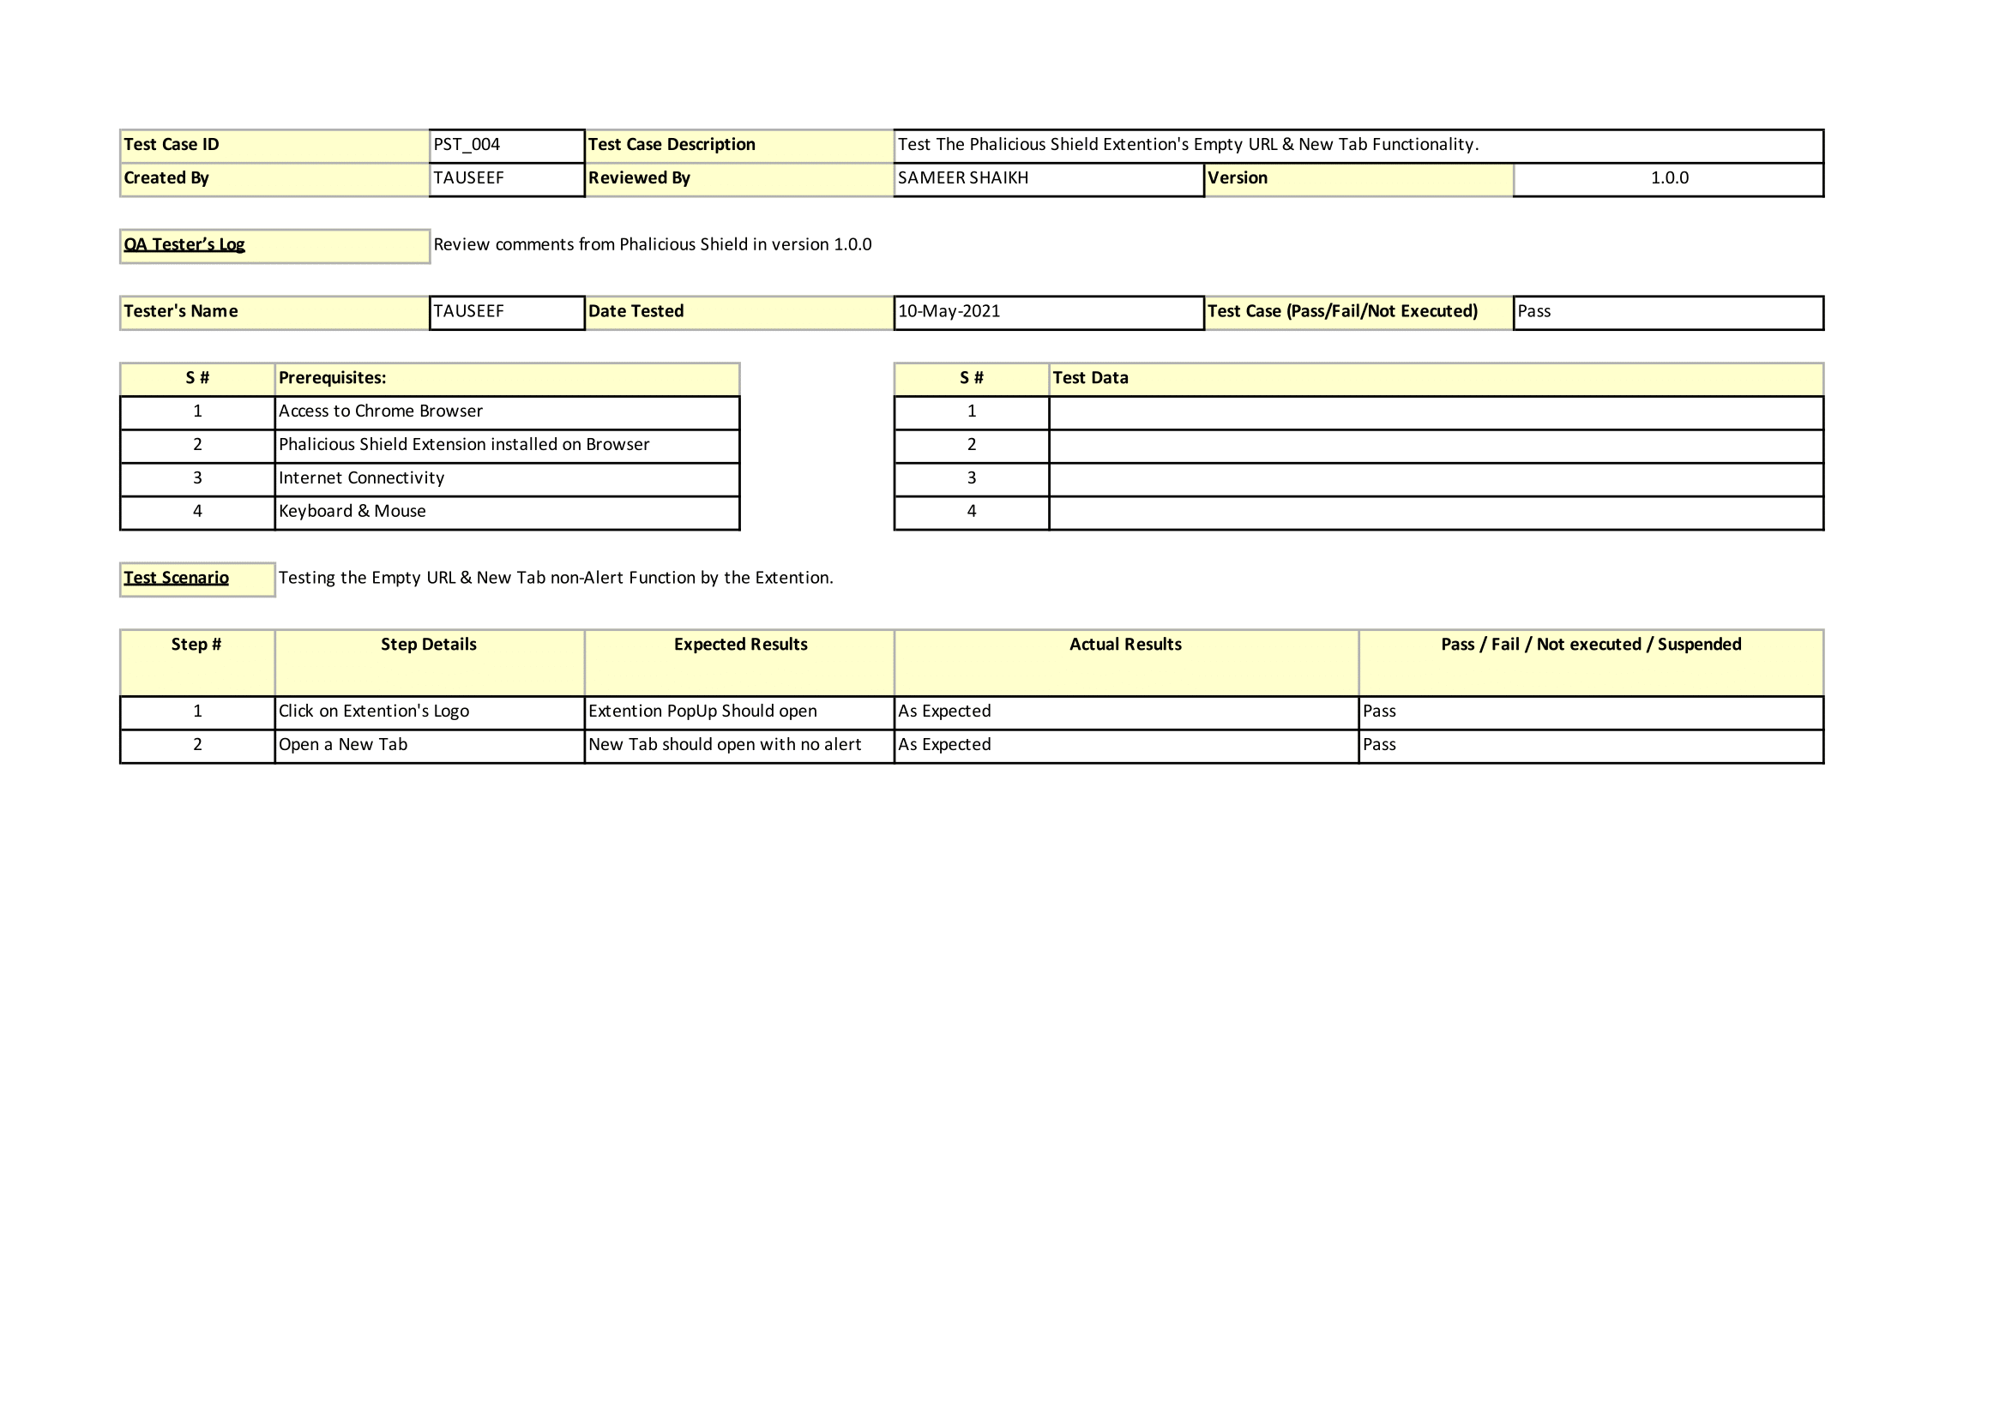

**Test case scenario 5: Testing the Real Life Functionality of the Extention.**

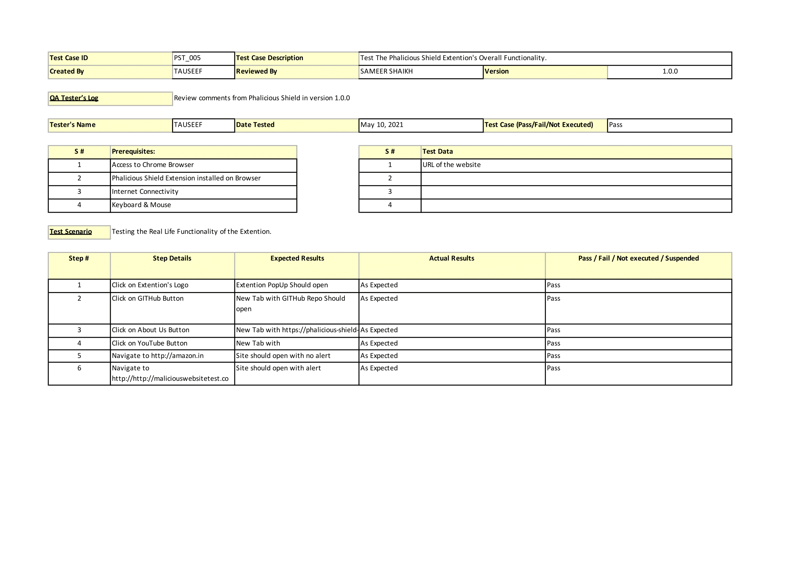

**Conclusion:**

|  |
| --- |
| With the help of this Experiment we get the information of developing test case scenarios. |